**9-1.Avoid_****infrared**

**1.Preparation**

1.You should learn about the position of the infrared module in the body of hellobot；

2.You should learn about the principle of the infrared obstacle avoidance.

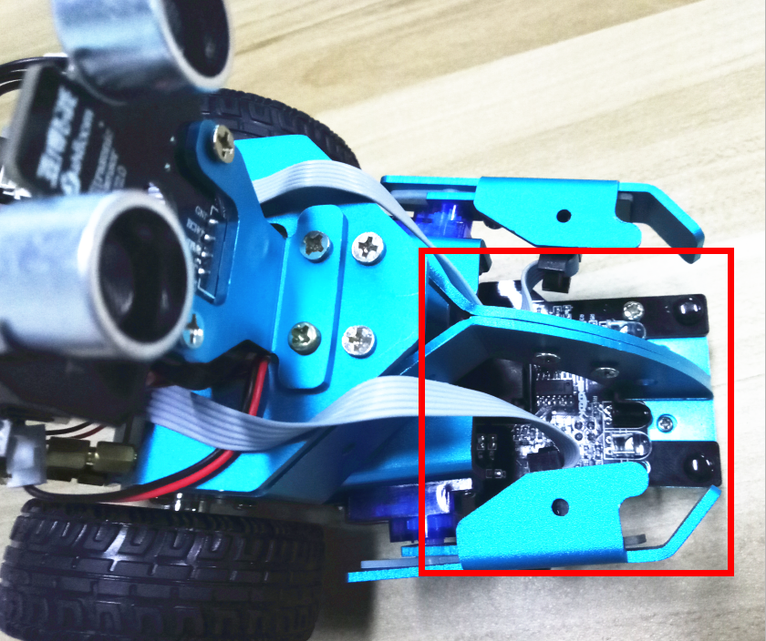

9-1-1 position of infraredmodule

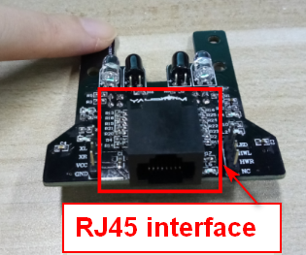

9-1-2 RJ45 interface of RGB tracking obstacle avoidance 3 in 1 module

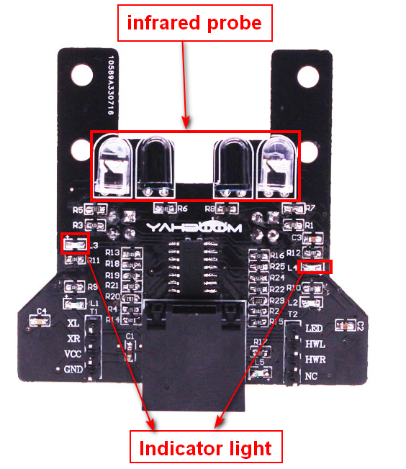

(b) infrared obstacle avoidance probe

9-1-2 RGB tracking obstacle avoidance 3 in 1 module

When there is an obstacle in front, indicator light is on, when there is not an obstacle in front, indicator light is off.

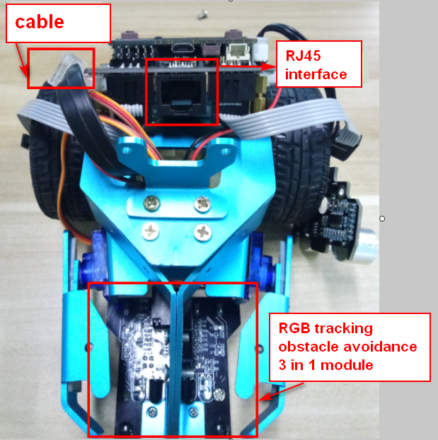

9-1-3 about wiring

The RGB tracking obstacle avoidance 3 in 1 module is installed under the robot arm of the HelloBot, and we need to use the network cable to connect the RGB tracking obstacle avoidance 3 in 1 module.

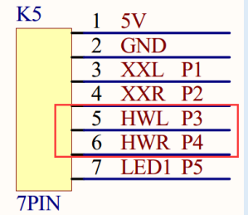

9-1-4 schematic

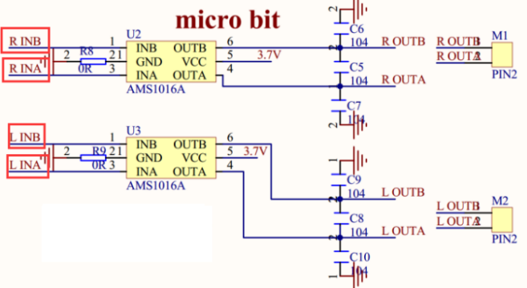

9-1-5 schematic of motor drive

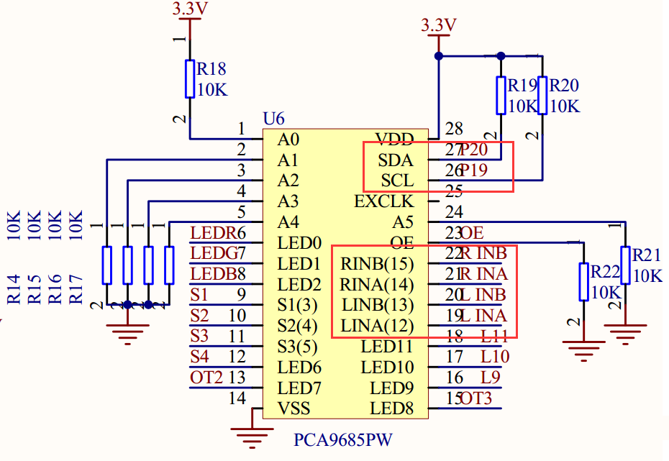

9-1-6 schematic of PCA9685PW

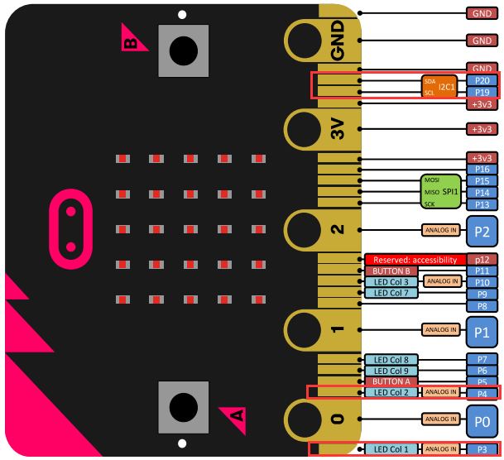

9-1-7 Pins of Micro:bit

From the schematic diagram. You can see that Pin _Trig of ultrasonic module(SCL) is connected to P3 of Micro:bit, Pin_Echo of ultrasonic module(SDA) connected to P4 of Micro:bit.

PCA9685PW connects micro:bit P19 and P20 pins for I2C communication.

Principle ofinfrared obstacle avoidance:

The basic principle of the infrared sensor to avoid obstacles is to use the reflective nature of the object. Within a certain range, if there is an obstacle, the infrared rays will encounter obstacle and will be reflected to reach the sensor receiving pin.

**Note:**The infrared obstacle avoidance sensor is not working properly due to the interference of outdoor light. This course needs to be carried out indoors and the curtains are covered to block the outdoor light.

**2.Learning goals**

In this experiment, we will study how to make HelloBot realize infrared obstacle avoidance function.

**3.Programming**

3.1 Programming online

**1) You should use the USB cable to connect the micro:bit to the computer, at this point, the computer will have a micro:bit U disk. You need to open it, click micro:bit website, then entered the micro:bit website** or you can enter the URL directly in your browser: http://microbit.org/

2) After entering the programming interface, you need to click Add package and copy the HelloBot package URL: https://github.com/lzty634158/HelloBot to the input field, click to confirm the add package. Then you can use the blocks of the HelloBot package.

3.2 Programming offline

1) You can double-click to use it. As shown in the following figure.

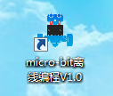

2) After entering the programming interface, you need to click Add package and copy the HelloBot package URL: https://github.com/lzty634158/HelloBot to the input field, click to confirm the add package. Then you can use the blocks of the HelloBot package.

Note: The package only needs to be added once. If you have added packages in the previous lessons, this course does not need to be added repeatedly.

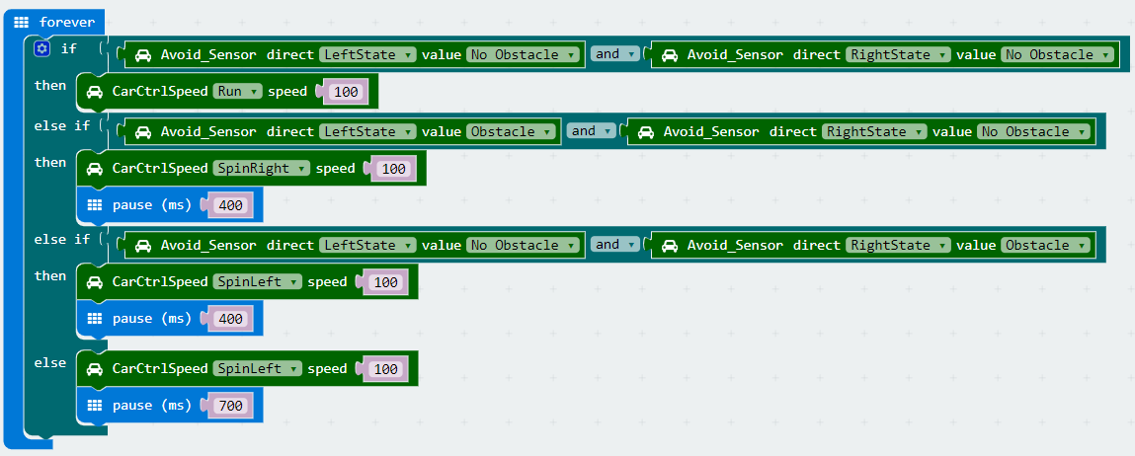

9-1-8 total program

The locations of blocks in the total program are shown in the following figure.

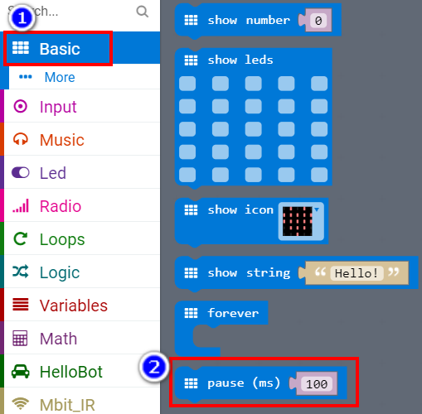

9-1-9

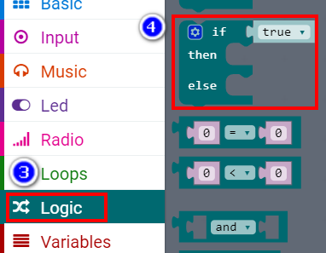

9-1-10

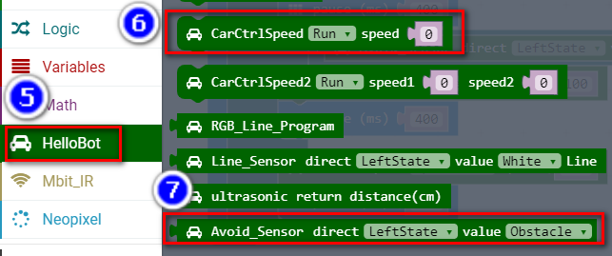

9-1-11

**4.Download programming**

You need to make sure that the micro:bit development board is connected to the computer. Then you should click on the download in the lower left corner as shown in P 9-1-11 to download the program to micro:bit.

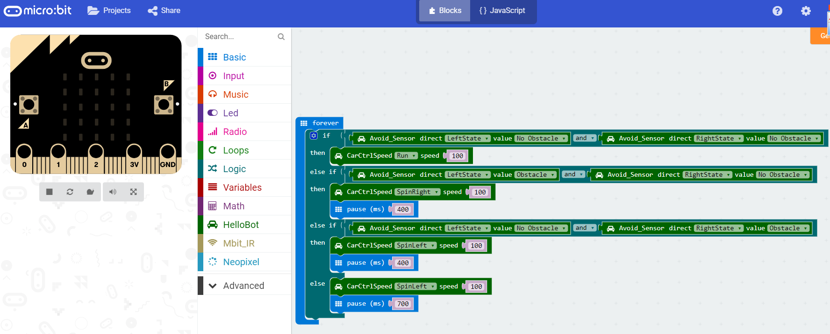

9-1-12

**5.Phenomenon**

After the code is uploaded. You can see that if there is an obstacle in front of the robot, the robot will turn right in place to avoid the obstacle; if there is an obstacle in the left front of the robot, the robot will turn right in place to avoid the obstacle; if there is an obstacle in the right front of the robot, the robot will turn left in place to avoid the obstacle.

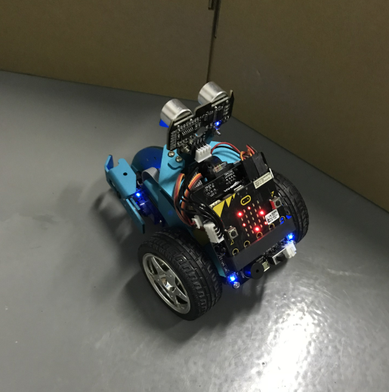

9-1-13